<Software> on the AWS Cloud

Quick Start Reference Deployment

<Month> 2020

<Name(s), Partner organization>

<Name(s)>, AWS Quick Start team

Visit our [GitHub repository](https://github.com/aws-quickstart/tbd) for source files and to post feedback,   
report bugs, or submit feature ideas for this Quick Start.

Contents

Overview 2

<software> on AWS 2

Cost and licenses 3

Architecture 3

Planning the deployment 5

Specialized knowledge 5

AWS account 5

Technical requirements 5

Deployment options 7

Deployment steps 7

Step 1. Sign in to your AWS account 7

Step 2. Subscribe to the <software> AMI 7

Step 3. Launch the Quick Start 8

Option 1: Parameters for deploying <software> into a new VPC 9

Option 2: Parameters for deploying <software> into an existing VPC 10

Step 4. Test the Deployment 12

Best practices for using <software> on AWS 12

Security 13

<Other useful information> 13

FAQ 13

Send us feedback 14

Additional resources 14

Document revisions 14

Style Guide 16

Terminology and usage 16

Bullet lists 16

Numbered lists for procedures 16

Tips, notes, and warnings 17

Graphics 17

Tables 18

References 18

Code 18

This Quick Start was created by <partner organization> in collaboration with Amazon Web Services (AWS).

[Quick Starts](http://aws.amazon.com/quickstart/) are automated reference deployments that use AWS CloudFormation templates to deploy key technologies on AWS, following AWS best practices.

# Overview

This Quick Start reference deployment guide provides step-by-step instructions for deploying <software> on the AWS Cloud.

This Quick Start is for users who <target audience and usage scenario>.

## <software> on AWS

<Lorem ipsum dolor sit amet, consectetur adipiscing elit, sed do eiusmod tempor incididunt ut labore et dolore magna aliqua.>

## Cost and licenses

You are responsible for the cost of the AWS services used while running this Quick Start reference deployment. There is no additional cost for using the Quick Start.

The AWS CloudFormation template for this Quick Start includes configuration parameters that you can customize. Some of these settings, such as instance type, affect the cost of deployment. For cost estimates, see the pricing pages for each AWS service you will use. Prices are subject to change.

**Tip** After you deploy the Quick Start, we recommend that you enable the [AWS Cost and Usage Report](https://docs.aws.amazon.com/awsaccountbilling/latest/aboutv2/billing-reports-gettingstarted-turnonreports.html). This report delivers billing metrics to an S3 bucket in your account. It provides cost estimates based on usage throughout each month and finalizes the data at the end of the month. For more information about the report, see the [AWS documentation](https://docs.aws.amazon.com/awsaccountbilling/latest/aboutv2/billing-reports-costusage.html).

<license information>This Quick Start requires a license for <software>. To use the Quick Start in your production environment, sign up for a license at <link>. When you launch the Quick Start, place the license key in an S3 bucket and specify its location.

If you don’t have a license, the Quick Start deploys with a trial license. The trial license gives you <n> days of free usage in a non-production environment. After this time, you can upgrade to a production license by following the instructions at <link>.

<AMI information>The Quick Start requires a subscription to the Amazon Machine Image (AMI) for <software>, which is available from [AWS Marketplace](https://aws.amazon.com/marketplace/). Additional pricing, terms, and conditions may apply. For instructions, see step 2 in the deployment section.

# Architecture

Deploying this Quick Start for a new virtual private cloud (VPC) with **default parameters** builds the following <software> environment in the AWS Cloud.

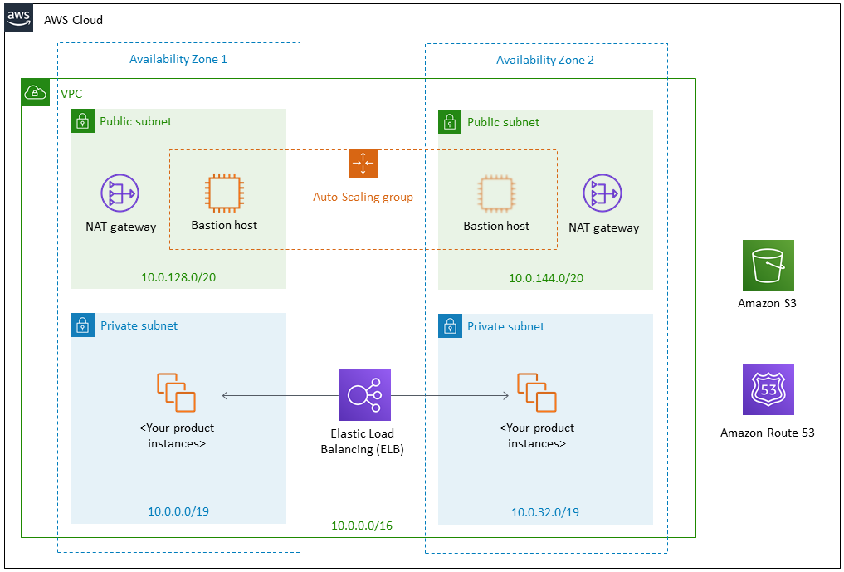

Figure 1: Quick Start architecture for <software> on AWS

The Quick Start sets up the following:

* A highly available architecture that spans two Availability Zones.*
* A VPC configured with public and private subnets, according to AWS best practices, to provide you with your own virtual network on AWS.*
* In the public subnets:
* Managed NAT gateways to allow outbound internet access for resources in the private subnets.*
* A Linux bastion host in an Auto Scaling group to allow inbound Secure Shell (SSH) access to EC2 instances in public and private subnets.*
* In the private subnets:
* <describe any additional components>.

**\*** The template that deploys the Quick Start into an existing VPC skips the components marked by asterisks and prompts you for your existing VPC configuration.

# Planning the deployment

## Specialized knowledge

This Quick Start assumes familiarity with <knowledge expectations>.

This deployment guide also requires a moderate level of familiarity with AWS services. If you’re new to AWS, visit the [Getting Started Resource Center](https://aws.amazon.com/getting-started/) and the [AWS Training and Certification website](https://aws.amazon.com/training/). These sites provide materials for learning how to design, deploy, and operate your infrastructure and applications on the AWS Cloud.

## AWS account

If you don’t already have an AWS account, create one at [https://aws.amazon.com](https://aws.amazon.com/) by following the on-screen instructions. Part of the sign-up process involves receiving a phone call and entering a PIN using the phone keypad.

Your AWS account is automatically signed up for all AWS services. You are charged only for the services you use.

## Technical requirements

Before you launch the Quick Start, your account must be configured as specified in the following table. Otherwise, deployment might fail.

|  |  |  |  |  |  |  |  |  |  |  |  |  |  |  |  |  |  |  |  |
| --- | --- | --- | --- | --- | --- | --- | --- | --- | --- | --- | --- | --- | --- | --- | --- | --- | --- | --- | --- |
| [Resources](http://docs.aws.amazon.com/general/latest/gr/aws_service_limits.html) | If necessary, request [service quota increases](https://console.aws.amazon.com/servicequotas/home?region=us-east-1#!/) for the following resources. You might need to do this if an existing deployment uses these resources, and you might exceed the default quotas with this deployment. The [Service Quotas console](https://console.aws.amazon.com/servicequotas/home?region=us-east-1#!/) displays your usage and quotas for some aspects of some services. For more information, see the [AWS documentation](https://docs.aws.amazon.com/servicequotas/latest/userguide/intro.html).   |  |  | | --- | --- | | Resource | This deployment uses | | VPCs | <n> | | Elastic IP addresses | <n> | | IAM security groups | <n> | | IAM roles | <n> | | Auto Scaling groups | <n> | | Application Load Balancers | <n> | | Network Load Balancers | <n> | | <type> instances | <n> | |
| [Regions](https://aws.amazon.com/about-aws/global-infrastructure/) | This deployment includes <service>, which isn’t currently supported in all AWS Regions. For a current list of supported Regions, see [Service Endpoints and Quotas](https://docs.aws.amazon.com/general/latest/gr/aws-service-information.html) in the AWS documentation. |
| [Key pair](https://docs.aws.amazon.com/AWSEC2/latest/UserGuide/ec2-key-pairs.html) | Make sure that at least one Amazon EC2 key pair exists in your AWS account in the Region where you plan to deploy the Quick Start. Make note of the key pair name. You need it during deployment. To create a key pair, follow the [instructions in the AWS documentation](https://docs.aws.amazon.com/AWSEC2/latest/UserGuide/ec2-key-pairs.html).  For testing or proof-of-concept purposes, we recommend creating a new key pair instead of using one that’s already being used by a production instance. |
| [IAM permissions](https://docs.aws.amazon.com/IAM/latest/UserGuide/access_policies_job-functions.html) | Before launching the Quick Start, you must log in to the AWS Management Console with IAM permissions for the resources and actions the templates deploy. The *AdministratorAccess* managed policy within IAM provides sufficient permissions, although your organization may choose to use a custom policy with more restrictions. |

## Deployment options

This Quick Start provides two deployment options:

* Deploy <software> into a new VPC (end-to-end deployment). This option builds a new AWS environment consisting of the VPC, subnets, NAT gateways, security groups, bastion hosts, and other infrastructure components. It then deploys <software> into this new VPC.
* Deploy <software> into an existing VPC. This option provisions <software> in your existing AWS infrastructure.

The Quick Start provides separate templates for these options. It also lets you configure CIDR blocks, instance types, and <software> settings, as discussed later in this guide.

# Deployment steps

## Step 1. Sign in to your AWS account

1. Sign in to your AWS account at <https://aws.amazon.com> with an IAM user role that has the necessary permissions. For details, see Planning the deployment earlier in this guide.
2. Make sure that your AWS account is configured correctly, as discussed in the Technical requirements section.

## Step 2. Subscribe to the <software> AMI

This Quick Start requires a subscription to the AMI for <software> in AWS Marketplace.

1. Sign in to your AWS account.
2. Open the page for the <software> AMI in AWS Marketplace, and then choose **Continue to Subscribe**.
3. Review the terms and conditions for software usage, and then choose **Accept Terms**.

A confirmation page loads, and an email confirmation is sent to the account owner. For detailed subscription instructions, see the [AWS Marketplace documentation](https://aws.amazon.com/marketplace/help/200799470).

1. When the subscription process is complete, exit out of AWS Marketplace without further action. **Do not** provision the software from AWS Marketplace—the Quick Start deploys the AMI for you.

## Step 3. Launch the Quick Start

**Notes** The instructions in this section reflect the older version of the AWS CloudFormation console. If you’re using the redesigned console, some of the user interface elements might be different.

You are responsible for the cost of the AWS services used while running this Quick Start reference deployment. There is no additional cost for using this Quick Start. For full details, see the pricing pages for each AWS service used by this Quick Start. Prices are subject to change.

1. Sign in to your AWS account, and choose one of the following options to launch the AWS CloudFormation template. For help with choosing an option, see deployment options earlier in this guide.

|  |  |
| --- | --- |
|  |  |
| Deploy <software> into a  new VPC on AWS | Deploy <software> into an  existing VPC on AWS |

**Important** If you’re deploying <software> into an existing VPC, make sure that your VPC has two private subnets in different Availability Zones for the workload instances, and that the subnets aren’t shared. This Quick Start doesn’t support [shared subnets](https://docs.aws.amazon.com/vpc/latest/userguide/vpc-sharing.html). These subnets require [NAT gateways](https://docs.aws.amazon.com/vpc/latest/userguide/vpc-nat-gateway.html) in their route tables, to allow the instances to download packages and software without exposing them to the internet.

Also, make sure that the domain name option in the DHCP options is configured as explained in the [Amazon VPC documentation](http://docs.aws.amazon.com/AmazonVPC/latest/UserGuide/VPC_DHCP_Options.html). You provide your VPC settings when you launch the Quick Start.

Each deployment takes about <x> minutes to complete.

1. Check the AWS Region that’s displayed in the upper-right corner of the navigation bar, and change it if necessary. This is where the network infrastructure for <software> will be built. The template is launched in the US East (Ohio) Region by default.

**Note** This deployment includes Amazon EFS, which isn’t currently supported in all AWS Regions. For a current list of supported Regions, see the [endpoints and quotas webpage](https://docs.aws.amazon.com/general/latest/gr/elasticfilesystem.html).

1. On the **Select Template** page, keep the default setting for the template URL, and then choose **Next**.
2. On the **Specify Details** page, change the stack name if needed. Review the parameters for the template. Provide values for the parameters that require input. For all other parameters, review the default settings and customize them as necessary.

In the following tables, parameters are listed by category and described separately for the two deployment options:

* Parameters for deploying <software> into a new VPC
* Parameters for deploying <software> into an existing VPC

When you finish reviewing and customizing the parameters, choose **Next**.

### Option 1: Parameters for deploying <software> into a new VPC

[View template](https://s3.amazonaws.com/quickstart-reference/)

*VPC network configuration:*

|  |  |  |
| --- | --- | --- |
| Parameter label (name) | Default | Description |
| Availability Zones (AvailabilityZones) | *Requires input* | The list of Availability Zones to use for the subnets in the VPC. The Quick Start uses two Availability Zones from your list and preserves the logical order you specify. |
| VPC CIDR (VPCCIDR) | 10.0.0.0/16 | The CIDR block for the VPC. |
| Private subnet 1 CIDR (PrivateSubnet1CIDR) | 10.0.0.0/19 | The CIDR block for the private subnet located in Availability Zone 1. |
| Private subnet 2 CIDR (PrivateSubnet2CIDR) | 10.0.32.0/19 | The CIDR block for the private subnet located in Availability Zone 2. |
| Public subnet 1 CIDR (PublicSubnet1CIDR) | 10.0.128.0/20 | The CIDR block for the public subnet located in Availability Zone 1. |
| Public subnet 2 CIDR (PublicSubnet2CIDR) | 10.0.144.0/20 | The CIDR block for the public subnet located in Availability Zone 2. |
| Permitted IP range (AccessCIDR) | *Requires input* | The CIDR IP range that is permitted to access <software>. We recommend that you set this value to a trusted IP range. For example, you might want to grant only your corporate network access to the software. |

*Amazon EC2 configuration:*

|  |  |  |
| --- | --- | --- |
| Parameter label (name) | Default | Description |
| Key pair name (KeyPairName) | *Requires input* | A public/private key pair, which allows you to connect securely to your instance after it launches. This is the key pair you created in your preferred AWS Region; see the Technical requirements section. |
| Parameter label (ParameterName) | *Optional* | Example of optional parameter. |

*AWS Quick Start configuration:*

**Note** We recommend keeping the default settings for the following two parameters, unless you are customizing the Quick Start templates for your own deployment projects. Changing these parameter settings automatically updates code references to point to a new Quick Start location. For additional details, see the [AWS Quick Start Contributor’s Guide](https://aws-quickstart.github.io/option1.html).

|  |  |  |
| --- | --- | --- |
| Parameter label (name) | Default | Description |
| Quick Start S3 bucket name (QSS3BucketName) | aws-quickstart | The S3 bucket you created for your copy of Quick Start assets, if you decide to customize the Quick Start for your own use. The bucket name can include numbers, lowercase letters, uppercase letters, and hyphens, but should not start or end with a hyphen. |
| Quick Start S3 key prefix (QSS3KeyPrefix) | quickstart-<company>-<product>/ | The [S3 key name prefix](https://docs.aws.amazon.com/AmazonS3/latest/dev/UsingMetadata.html) used to simulate a folder for your copy of Quick Start assets. You need to use this if you want to customize the Quick Start for your own use. This prefix can include numbers, lowercase letters, uppercase letters, hyphens, and forward slashes. |

### Option 2: Parameters for deploying <software> into an existing VPC

[View template](https://s3.amazonaws.com/quickstart-reference/)

*Network configuration:*

|  |  |  |
| --- | --- | --- |
| Parameter label (name) | Default | Description |
| VPC ID (VPCID) | *Requires input* | The ID of your existing VPC (e.g., vpc-0343606e). |
| Private subnet 1 ID (PrivateSubnet1ID) | *Requires input* | The ID of the private subnet in Availability Zone 1 in your existing VPC (e.g., subnet-a0246dcd). |
| Private subnet 2 ID (PrivateSubnet2ID) | *Requires input* | The ID of the private subnet in Availability Zone 2 in your existing VPC (e.g., subnet-b58c3d67). |
| Bastion security  group ID  (BastionSecurityGroup ID) | *Requires input* | The ID of the bastion security group in your existing VPC (e.g., sg-7f16e910). |

*Amazon EC2 configuration:*

|  |  |  |
| --- | --- | --- |
| Parameter label (name) | Default | Description |
| Key pair name (KeyPairName) | *Requires input* | A public/private key pair, which allows you to connect securely to your instance after it launches. This is the key pair you created in your preferred AWS Region; see the Technical requirements section. |
| Parameter label (ParameterName) | *Optional* | Example of optional parameter. |

*AWS Quick Start configuration:*

**Note** We recommend keeping the default settings for the following two parameters, unless you are customizing the Quick Start templates for your own deployment projects. Changing these parameter settings automatically updates code references to point to a new Quick Start location. For additional details, see the [AWS Quick Start Contributor’s Guide](https://aws-quickstart.github.io/option1.html).

|  |  |  |
| --- | --- | --- |
| Parameter label (name) | Default | Description |
| Quick Start S3 bucket name (QSS3BucketName) | aws-quickstart | The S3 bucket you have created for your copy of Quick Start assets, if you decide to customize the Quick Start for your own use. The bucket name can include numbers, lowercase letters, uppercase letters, and hyphens, but should not start or end with a hyphen. |
| Quick Start S3 key prefix (QSS3KeyPrefix) | quickstart-<company>-<product>/ | The [S3 key name prefix](https://docs.aws.amazon.com/AmazonS3/latest/dev/UsingMetadata.html) used to simulate a folder for your copy of Quick Start assets. You need to use this if you want to customize the Quick Start for your own use. This prefix can include numbers, lowercase letters, uppercase letters, hyphens, and forward slashes. |

1. On the **Options** page, you can [specify tags](https://docs.aws.amazon.com/AWSCloudFormation/latest/UserGuide/aws-properties-resource-tags.html) (key-value pairs) for resources in your stack and [set advanced options](https://docs.aws.amazon.com/AWSCloudFormation/latest/UserGuide/cfn-console-add-tags.html). When you’re done, choose **Next**.
2. On the **Review** page, review and confirm the template settings. Under **Capabilities**, select the two check boxes to acknowledge that the template creates IAM resources and might require the capability to auto-expand macros.
3. Choose **Create** to deploy the stack.
4. Monitor the status of the stack. When the status is **CREATE_COMPLETE**, the <software> cluster is ready.
5. Use the URLs displayed in the **Outputs** tab for the stack to view the resources that were created.

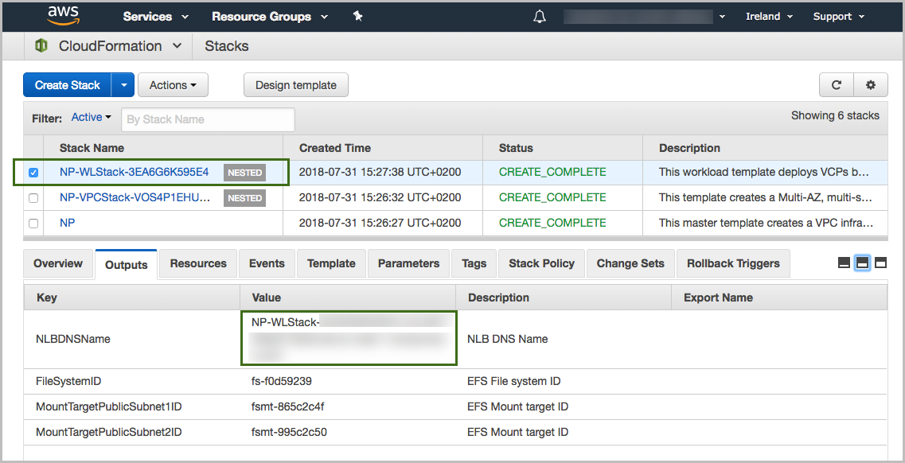

Figure 2: <software> outputs after successful deployment

## Step 4. Test the deployment

<Lorem ipsum dolor sit amet, consectetur adipiscing elit, sed do eiusmod tempor incididunt ut labore et dolore magna aliqua.>

# Best practices for using <software> on AWS

<Lorem ipsum dolor sit amet, consectetur adipiscing elit, sed do eiusmod tempor incididunt ut labore et dolore magna aliqua.>

# Security

<Lorem ipsum dolor sit amet, consectetur adipiscing elit, sed do eiusmod tempor incididunt ut labore et dolore magna aliqua.>

# <Other useful information>

<Lorem ipsum dolor sit amet, consectetur adipiscing elit, sed do eiusmod tempor incididunt ut labore et dolore magna aliqua.>

# FAQ

**Q.** I encountered a **CREATE_FAILED** error when I launched the Quick Start.

**A.** If AWS CloudFormation fails to create the stack, we recommend that you relaunch the template with **Rollback on failure** set to **No**. (This setting is under **Advanced** in the AWS CloudFormation console, **Options** page.) With this setting, the stack’s state is retained and the instance is left running, so you can troubleshoot the issue. (For Windows, look at the log files in %ProgramFiles%\Amazon\EC2ConfigService and C:\cfn\log.)

**Important** When you set **Rollback on failure** to **No**, you continue to incur AWS charges for this stack. Please make sure to delete the stack when you finish troubleshooting.

For additional information, see [Troubleshooting AWS CloudFormation](https://docs.aws.amazon.com/AWSCloudFormation/latest/UserGuide/troubleshooting.html) on the AWS website.

**Q.** I encountered a size limitation error when I deployed the AWS CloudFormation templates.

**A.** We recommend that you launch the Quick Start templates from the links in this guide or from another S3 bucket. If you deploy the templates from a local copy on your computer or from a non-S3 location, you might encounter template size limitations. For more information about AWS CloudFormation quotas, see the [AWS documentation](http://docs.aws.amazon.com/AWSCloudFormation/latest/UserGuide/cloudformation-limits.html).

# Send us feedback

To post feedback, submit feature ideas, or report bugs, use the **Issues** section of the [GitHub repository](https://github.com/aws-quickstart/tbd) for this Quick Start. If you’d like to submit code, please review the [Quick Start Contributor’s Guide](https://aws-quickstart.github.io/).

# Additional resources

AWS resources

* [Getting Started Resource Center](https://aws.amazon.com/getting-started/)
* [AWS General Reference](https://docs.aws.amazon.com/general/latest/gr/)
* [AWS Glossary](https://docs.aws.amazon.com/general/latest/gr/glos-chap.html)

AWS services

* [AWS CloudFormation](https://docs.aws.amazon.com/cloudformation/)
* [Amazon EBS](https://docs.aws.amazon.com/AWSEC2/latest/UserGuide/AmazonEBS.html)
* [Amazon EC2](https://docs.aws.amazon.com/ec2/)
* [IAM](https://docs.aws.amazon.com/iam/)
* [Amazon VPC](https://docs.aws.amazon.com/vpc/)

<software> documentation

* <link>

Other Quick Start reference deployments

* [AWS Quick Start home page](https://aws.amazon.com/quickstart/)

# Document revisions

|  |  |  |
| --- | --- | --- |
| Date | Change | In sections |
| <month> 2019 | Initial publication | — |

© 2020, Amazon Web Services, Inc. or its affiliates, and <partner organization>. All rights reserved.

**Notices**

This document is provided for informational purposes only. It represents AWS’s current product offerings and practices as of the date of issue of this document, which are subject to change without notice. Customers are responsible for making their own independent assessment of the information in this document and any use of AWS’s products or services, each of which is provided “as is” without warranty of any kind, whether express or implied. This document does not create any warranties, representations, contractual commitments, conditions or assurances from AWS, its affiliates, suppliers or licensors. The responsibilities and liabilities of AWS to its customers are controlled by AWS agreements, and this document is not part of, nor does it modify, any agreement between AWS and its customers.

The software included with this paper is licensed under the Apache License, Version 2.0 (the "License"). You may not use this file except in compliance with the License. A copy of the License is located at <http://aws.amazon.com/apache2.0/> or in the "license" file accompanying this file. This code is distributed on an "AS IS" BASIS, WITHOUT WARRANTIES OR CONDITIONS OF ANY KIND, either express or implied. See the License for the specific language governing permissions and limitations under the License.

# Style Guide

Delete this section after following these guidelines.

## Terminology and usage

* For a word list and usage guidelines for AWS content, see the [AWS Usage Dictionary](https://alpha-docs-aws.amazon.com/awsstyleguide/latest/styleguide/dictionary.html) (internal AWS use only).
* For AWS service names and allowed variations, see the [AWS Service Names](https://w.amazon.com/bin/view/AWSDocs/editing/service-names/) wiki page (internal AWS use only).

## Bullet lists

* Use the **List Bullet** style instead of using the bullets control on the Word ribbon.
* Use the **List Paragraph** style for additional paragraphs under the bullet.
* Use nested bullet lists sparingly.
* Use the **List Bullet 2** style for second-level bulleted lists.
* Keep both first-level and second-level lists short. Three to seven items is a good rule of thumb to follow.
* Manually change the spacing after the last item to 14 pt.

## Numbered lists for procedures

1. Use a numbered list only when there’s a sequence (of steps, or priorities, etc.) involved. (Note that we’re using a numbered list in this section to illustrate formatting, but this information would require bullets, not numbers.)
2. Use the **List Number** style instead of using the numbered list control on the Word ribbon.
3. Use the **List Paragraph** style for additional paragraphs under the number.
4. Use nested lists sparingly.
5. Use the **List Number 2** style for second-level numbered lists.
6. Manually change the spacing after the last item to 14 pt.

## Tips, notes, and warnings

Use the **Note** style, which provides the following formatting. Change “Note” to “Tip” or “Warning” as needed.

**Note** You are responsible for all costs incurred by your use of the AWS services used while running this Quick Start Reference Deployment. See the pricing pages of the specific AWS services you will be using for full details.

## Graphics

* Use the **Picture** style, which centers the illustration.
* Below the figure, add the figure caption using the **Caption** style. Specify the number in the format **Figure *n*: Caption**. Use sentence capitalization for captions (that is, just capitalize the first word and any proper nouns).
* For architecture diagrams, use our [PowerPoint template](https://github.com/aws-quickstart/quickstart-examples/raw/master/doc/Quick%20Start%20architecture%20diagram.pptx) template and the [AWS simple icons](https://aws.amazon.com/architecture/icons/), and send us the source file.
* For screenshots:
* Use where the UI is confusing or complex. Avoid using screenshots for login screens or any UI that’s self-explanatory.
* Crop screenshots to the smallest useful size, centering on the topic of discussion but showing just enough surrounding area to establish context.
* Blur all personal information.
* Fill in values when displaying settings.
* If capturing a browser screen, try making the window smaller to decrease the width of the image and to minimize the need to resize it.
* Highlight hard-to-find elements with a green arrow or rectangle with no shadows. Or send us the screenshot without highlighting and let us know where we need to add it.
* Provide an explanation in text. Don’t rely on screenshots alone to convey information.
* For detailed guidelines, see [Art](https://alpha-docs-aws.amazon.com/awsstyleguide/latest/styleguide/graphics.html) in the *AWS Style Guide* (internal AWS use only).

## Tables

* Create a table in Word (**Insert** > **Table**), and apply the **AWS** table style from the menu on the **Table Tools**, **Design** tab. There’s also an **AWS wide** style if you need a wider table.
* Use the **Table text** style for the contents of the table.
* Add boldface for headings.
* Turn on the **Repeat Header Rows** option on the **Table Tools**, **Layout** tab.

|  |  |  |  |  |
| --- | --- | --- | --- | --- |
|  | January | February | March | April |
| North | Red | Green | Blue | Black |
| South | Red | Green | Blue | Black |
| East | Red | Green | Blue | Black |
| West | Red | Green | Blue | Black |

## References

* Use the **Hyperlink** style.
* Use the title of the paper or website as link text. Don’t use phrases like “click here” or “this website” for your links.
* In some cases, you might want to shorten the link text and weave it into the sentence, e.g., “Create a [key pair](http://docs.aws.amazon.com/AWSEC2/latest/UserGuide/ec2-key-pairs.html) in your preferred AWS Region.”
* Don’t display the URL in text unless you’re linking to a home page or to a main section under the home page.
* When providing information from other sources, be sure to use your own words. Use short quotations if necessary. It’s OK to use text from the AWS documentation.

## Code

For code that appears within a sentence, use the Code Inline style.

For code blocks, use the **Code Snippet** style:

"Conditions": {

"GovCloudCondition": {

"Fn::Equals": [

{

"Ref": "AWS::Region"

},

"us-gov-west-1"

]

}

},

In the HTML version of the deployment guide, we can use syntax highlighting for selected languages, including JSON, PowerShell, Bash, and Python. The PDF format doesn’t support syntax highlighting.